Shropdoc GP Members Performers’ List
Application Process
In order to do OOHs shifts for Shropdoc and see patients whose episode of care arises from within Powys you are required by law to be on a Welsh Performers’ List (WPL).

Separate to the legal requirement, in order to ensure you are covered by the state-backed indemnity scheme in Wales you must also join a WPL.

Any GP who works OOHs for Shropdoc beyond 31ST October who cannot show that they have at least provisional registration with the WPL will not be able to work OOHs shifts as they will not be insured to do so.

Purpose
The purpose of this presentation is to clarify the steps Shropdoc GP Members need to take to reassure themselves they are adequately covered for clinical negligence that may arise from treating patients presenting via Shropdoc’s OOHs services in England and Wales.
But the presentation is provided as a guide only – If you have any questions after reading it then please contact: clinical.risk@shropdoc.nhs.uk putting WPL in the subject line

Background
On 1st April 2019 NHS England and Wales simultaneously introduced a state-backed indemnity scheme for Primary Care
http://www.nwssp.wales.nhs.uk/general-medical-practice-indemnity (Wales)
https://resolution.nhs.uk/services/claims-management/clinical-schemes/clinicalnegligence-scheme-for-general-practice/ (England)

These schemes removed the requirement for Shropdoc GP Members to maintain clinical negligence indemnity via their Medical Defence Organisations (MDO) for OOHs work
If an English GP wishes to ensure indemnity for treating Powys patients e.g. in triage or at Shrewsbury, Telford, Ludlow bases or the Powys Community Hospitals, then they must join the Welsh List to gain access to the CNSGP (Wales) scheme known as GMPI.

The reverse is true for Welsh GPs who wish to treat English patients but importantly the Powys Health Board has taken the position that Welsh GPs may decline to see patients whose episode of care arises in England, which removes the need for Welsh GPs to register on an English List unless they want to do dedicated triage for Shropdoc. GPs may wish to retain some Professional Indemnity i.e. separate from clinical negligence indemnity with their own MDOs to cover themselves for support not currently provided by the schemes detailed above.

Advice varies between defence organisations so it is best to check

Clear as Mud
The requirement to dual register comes from the way the Shropdoc OOHs services are commissioned across the border between England and Wales.
The state backed indemnity scheme covering each consultation is determined by where the patient’s episode of care arises

If a patient’s episode of care arises from within the geographical boundaries of Wales (regardless of whether they are registered in England) then it is the Welsh scheme that applies

The reverse is also true

Important Legal Info
Entirely separate from the clinical negligence requirements, if you intend seeing patients both sides of the border, there is a legal requirement to dual register

I’m a Powys based GP on the WPL who works at Newtown OOHs. I understand I can decline to triage patients presenting in the English 111 system and also decline travelling into England to see patients because that is what the Health Board and Welsh Government agreed.
Correct. Unless dual registered in England and appropriately indemnified through the CNSGP (England) scheme you can decline as above
But we hope that Welsh Shropdoc GPs will see the value of dual registering to enable clinical and operational flexibility that works both ways for the benefit of all patients

I work solely at the Shropdoc Urgent Care Centre (UCC). Do I still need to apply to the WPL
No. Even if a Welsh patient turns up at the UCC they are presenting under the English arrangements and you will be covered by the hospital based state backed indemnity scheme (CNST) https://resolution.nhs.uk/services/claimsmanagement/clinical-schemes/clinicalnegligence-scheme-for-trusts/
If you ever wanted to work for Shropdoc OOHs elsewhere then you would have to join the WPL
I work solely at Telford Base and I am unlikely to see a patient whose episode of care arises in Wales. Why do I have to join the WPL?
It is not uncommon for paediatric patients to be asked to go to a base appointment at Telford because the triage clinician consider they may need admission to the PRH Women and Children‘s Centre
This includes patients whose episode of care arises in Powys it follows therefore that in order to ensure clinical negligence cover you will have to join the WPL

Complete Form MPL4A
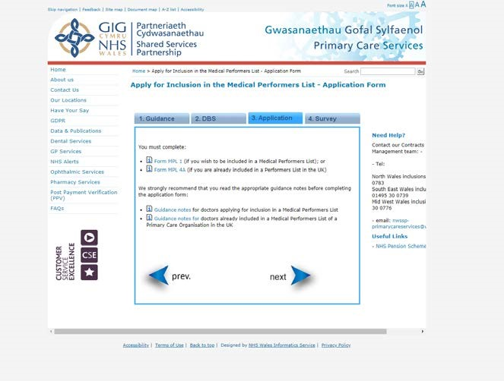
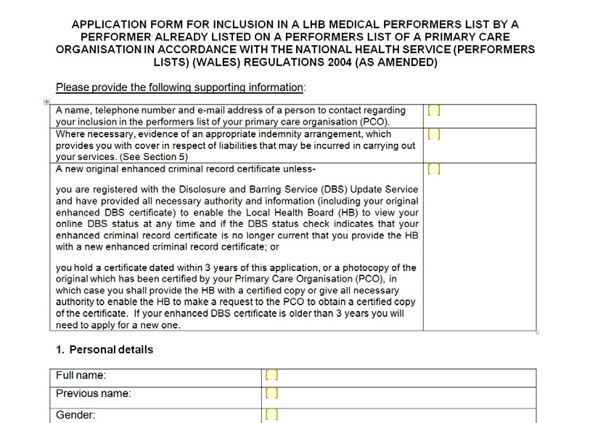
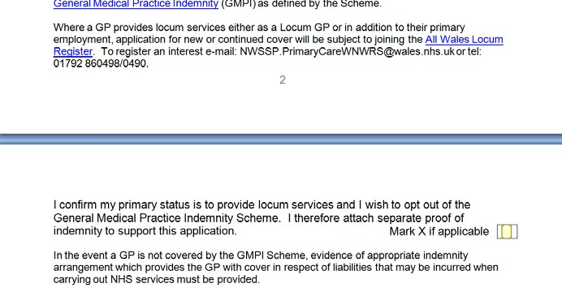
• Page 1
•
Box 1 –
enter area team
info (see next slide)
•
Box 2 –
ignore if you will
rely on the state-backed
scheme
•
Also do not tick box in
section 5 if you rely on
the state backed
indemnity)
Finding Your Area Team Info For Box 2
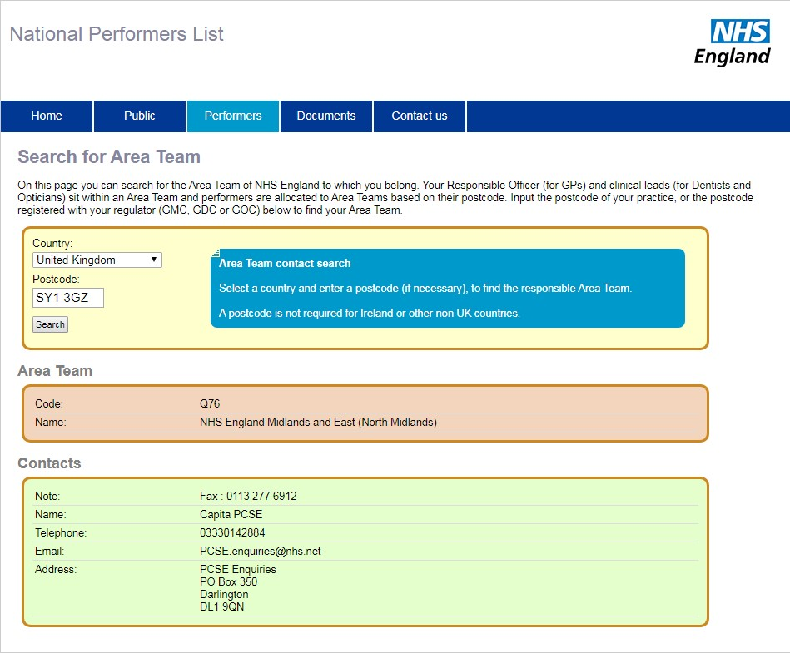
- Go to this website:
https://www.performer. england.nhs.uk/AT/Sear chByPostcode

Follow instructions • Use Area Team Info as detailed after you search on your postcode in the MPL4A form

DBS
- There is no requirement to do a face to face meeting in Cardiff for the purposes of a new DBS despite what you might read.
- Shropdoc can facilitate a new DBS for you but we cannot pay for it – contact us for info • Remember to subscribe to the DBS update Service for £13 per annum once you’ve applied but there is a time limit so be quick (next slide for screen shot)
DBS Update Service
https://secure.crbonline.gov.uk/crsc/apply?execution=e1s1
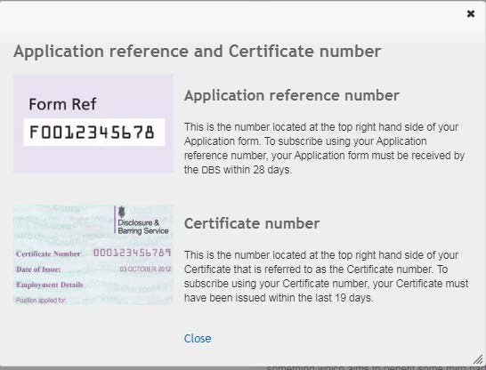

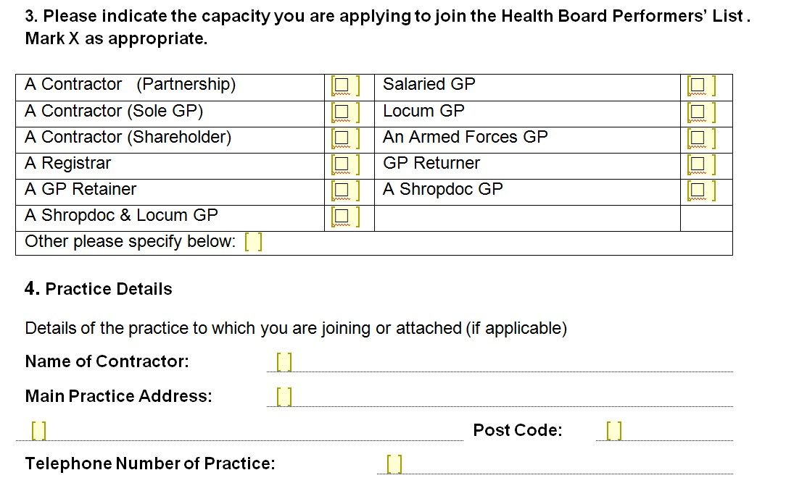
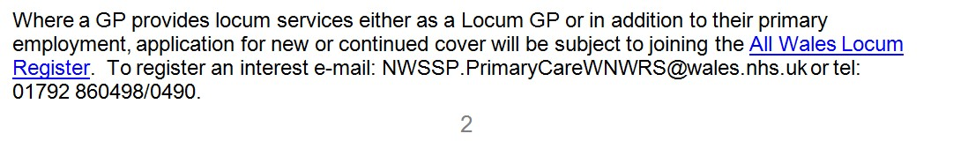
The WPL Process

–
Tel: 01743 454900
*
- Paragraphs 1 and 2 – Complete what it asks

Paragraph 3
  - If you ever intend to Locum in Wales then tick ‘A
Shropdoc and Locum GP’ and also contact the Locum List to register (details at bottom of page 2)* – If you do not intend to Locum in Wales then tick, ‘A Shropdoc GP’
- Paragraph 4
  - Put down Shropdoc and our address:
  - Unit A 3 Longbow Close
  - Shrewsbury
  - SY1 3GZ
Box at Top of Page 3
Do not tick the box at the top of page 3 unless
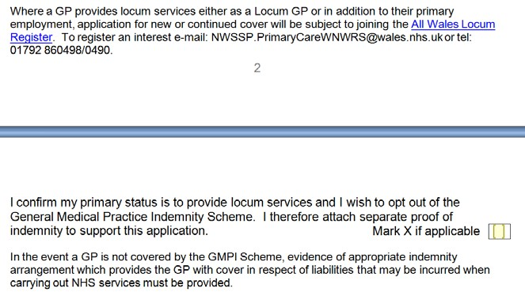
you have retained your
own MDO cover

What Happens Next
- Once you have submitted your application you will receive correspondence from NHS Wales SSP asking for:
  - You to send your original DBS Certificate
  - Current CV or list of recent jobs
  - Copy of degree certificate or statement saying that you cannot locate it in which case Powys HB will waive this requirement
  - 2 referees (one of which can be Simon Chapple)
- You will receive a letter saying that you have 3-months provisional registration while your application is processed

Operational Impact
A soft line will be drawn down the border meaning that the Despatch team will not routinely direct Powys based Shropdoc teams across the border
They will however retain the right to discuss the clinical situation with Powys based teams who may be dual indemnified and capable of seeing patients across the border
Questions?
- Simon Chapple: 01743 454900
- Clinical.risk@shropdoc.nhs.uk putting ‘WPL’ in the subject line

